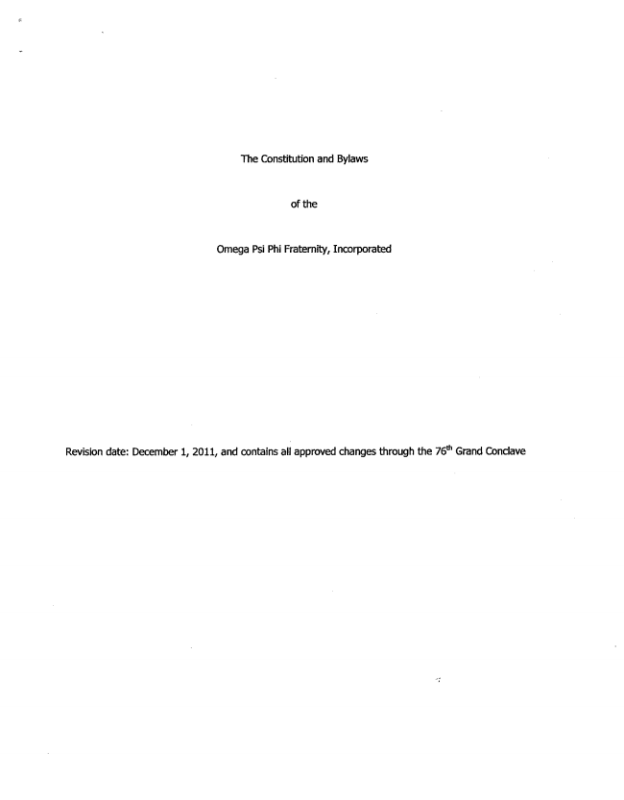

The Constitution and Bylaws
of the
Omega Psi Phi Fraternity, Incorporated
Revision date: December 1, 2011, and contains all approved changes through the 76" Grand Conclave

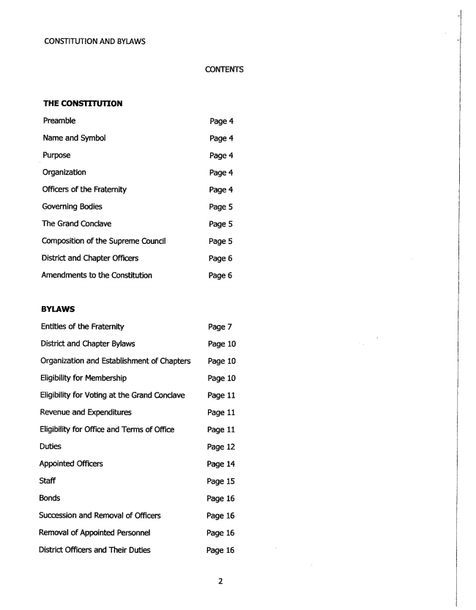

CONSTITUTION AND BYLAWS
THE CONSTITUTION
Preamble
Name and Symbol
- Purpose
Organization
Officers of the Fraternity
Governing Bodies
The Grand Conclave
Composition of the Supreme Council
District and Chapter Officers
Amendments to the Constitution
BYLAWS
Entities of the Fraternity
District and Chapter Bylaws
Organization and Establishment of Chapters
Eligibility for Membership
Eligibility for Voting at the Grand Conclave
Revenue and Expenditures
Eligibility for Office and Terms of Office
Duties
Appointed Officers
Staff
Bonds
Succession and Removal of Officers
Removal of Appointed Personnel
District Officers and Their Duties
CONTENTS
Page 4
Page 4
Page 4
Page 4
Page 4
Page 5
Page 5
Page 5
Page 6
Page 6
Page 7
Page 10
Page 10
Page 10
Page 11
Page 11
Page 11
Page 12
Page 14
Page 15
Page 16
Page 16
Page 16
Page 16



CONSTITUTION AND BYLAWS
Other Officers or Personnel
Chapter Officers and Their Duties
Organizational Committees
Standing Committees
Amendments to Bylaws
Page 18
Page 18
Page 20
Page 21
Page 23

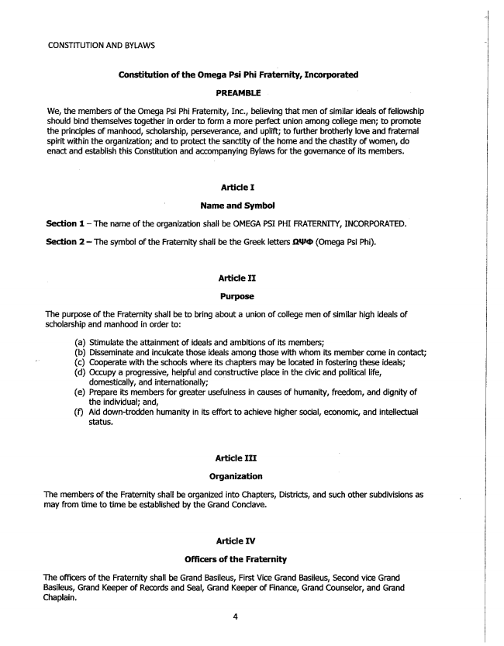

CONSTITUTHON AND BYLAWS
Constitution of the Omega Psi Phi Fraternity, Incorporated
PREAME LE
We, the members of the Omega Psi Phi Fraternity, Inc., believing that men of similar ideals of fellowship should bind themselves together in order to form a more perfect union among college men; to promote the principles of manhood, scholarship, perseverance, and uplift; to further brotherly love and fraternal spirit within the organization; and to protect the sanctity of the home and the chastity of women, do enact and establish this Constitution and accompanying Bylaws for the governance of its members.
Article I
Name and Symbol
Section 1 — The name of the organization shall be OMEGA PSI PHI FRATERNITY, INCORPORATED.
Section 2-The symbol of the Fraternity shall be the Greek letters opep (Omega Psi Phi).
Articie II
Purpose
The purpose of the Fraternity shall be to bring about a union of college men of similar high ideals of scholarship and manhood in order to:
(a) Stimulate the attainment of ideals and ambitions of its members; (b) Disseminate and inculcate those ideals among those with whom its member come in contact; (c) Cooperate with the schools where its chapters may be located in fostering these ideals; (d) Occupy a progressive, helpful and constructive place in the civic and political life,
domestically, and internationally; (e) Prepare its members for greater usefulness in causes of humanity, freedom, and dignity of
the individual; and, (f) Aid down-trodden humanity in its effort to achieve higher social, economic, and intellectual
status.
Article If I
Organization
The members of the Fratermity shall be organized into Chapters, Districts, and such other subdivisions as may from time to time be established by the Grand Conclave.
Article IV
Officers of the Fraternity
The officers of the Fraternity shall be Grand Basileus, First Vice Grand Basileus, Second vice Grand Basileus, Grand Keeper of Records and Seal, Grand Keeper of Finance, Grand Counselor, and Grand Chaplain.

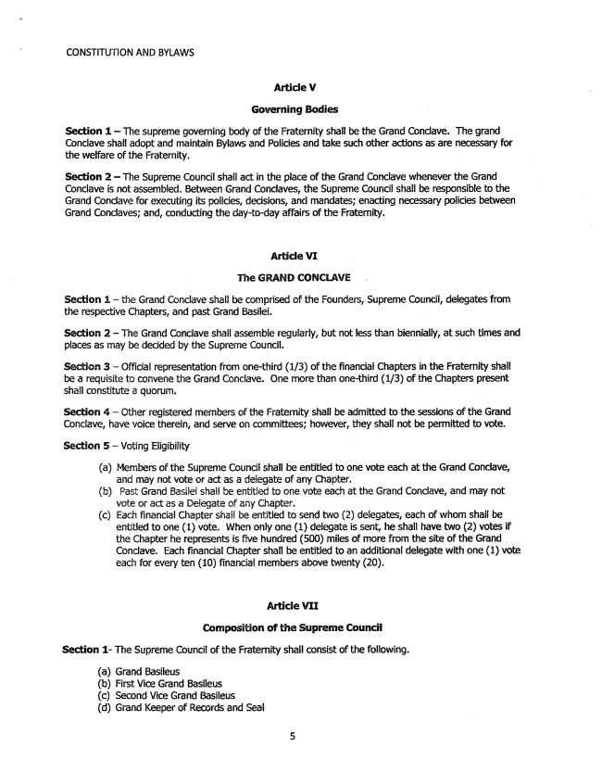

CONSTITUTION AND BYLAWS
Article V
Governing Bodies
Section 1 — The supreme governing body of the Fraternity shall be the Grand Condave. The grand Conclave shall adopt and maintain Bylaws and Policies and take such other actions as are necessary for the welfare of the Fraternity.
Section 2 – The Supreme Council shall act in the place of the Grand Conclave whenever the Grand Conclave is not assembled. Between Grand Conclaves, the Supreme Council shall be responsible to the Grand Conclave for executing its policies, decisions, and mandates; enacting necessary policies between Grand Conclaves; and, conducting the day-to-day affairs of the Fraternity.
Article VI
書『リé G設AND coNcLAvE
Section 3 – the Grand Conciave shall be comprised of the Founders, Supreme Council, delegates from the respective Chapters, and past Grand Basilei.
Section 2 – The Grand Conclave shall assemble regularly, but not less than biennially, at such times and places as may be decided by the Supreme Council. .
Section 3 – Official representation from one-third (1/3) of the financial Chapters in the Fraternity shall be a requisite to convene the Grand Conclave. One more than one-third (1/3) of the Chapters present shall constitute a quorum.
Section 4 – Other registered members of the Fraternity shall be admitted to the sessions of the Grand Conclave, have voice therein, and serve on committees; however, they shall not be permitted to vote.
Section 5 – Voting Eligibility
(a) Members of the Supreme Council shall be entitled to one vote each at the Grand Conclave,
and may not vote or act as a delegate of any Chapter. (b) Past Grand Basilei shall be entitled to one vote each at the Grand Conclave, and may not
vote or act as a Delegate of any Chapter, (c) Each financial Chapter shall be entitled to send two (2) delegates, each of whom shall be
entitled to one (1) vote. When only one (1) delegate is sent, he shall have two (2) votes if the Chapter he represents is five hundred (500) miles of more from the site of the Grand Conclave. Each financial Chapter shall be entitled to an additional delegate with one (1) vote each for every ten (10) financial members above twenty (20).
Article VII
Composition of the Supreme Council
Section 1- The Supreme Council of the Fraternity shall consist of the following.
(a) Grand Basileus (b) First Vice Grand Basileus (c) Second Vice Grand Basileus (d) Grand Keeper of Records and Seal

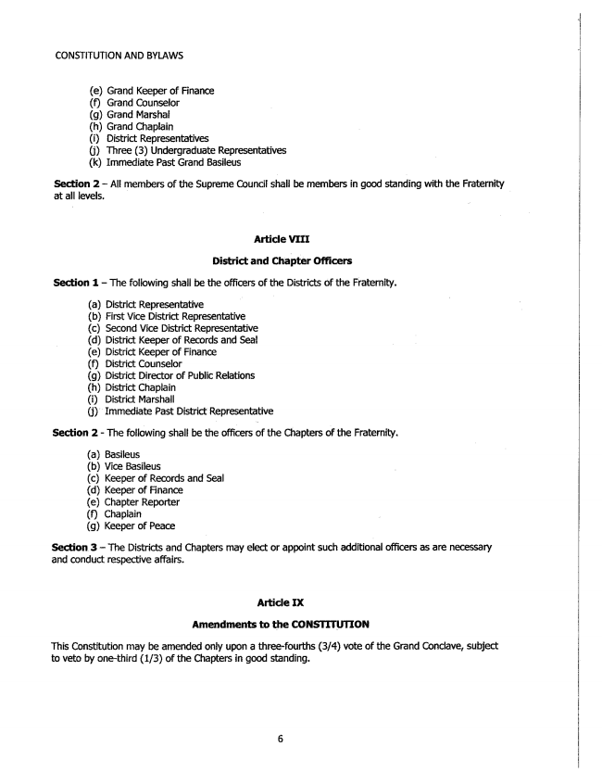

CONSTITUTION AND BYLAWS
(e) Grand Keeper of Finance (f) Grand Counselor
(g) Grand Marshal
(h) Grand Chaplain (i) District Representatives (j) Three (3) Undergraduate Representatives (k) Immediate Past Grand Basileus
Section 2 - All members of the Supreme Council shall be members in good standing with the Fraternity at all levels.
Articie VIII
District and Chapter officers
Section 1 — The following shall be the officers of the Districts of the Fraternity.
(a) District Representative (b) First Vice District Representative (c) Second Vice District Representative (d) District Keeper of Records and Seal (e) District Keeper of Finance (f) District Counselor (g) District Director of Public Relations (h) District Chaplain
(i) District Marshall (j) Immediate Past District Representative
Section 2 - The following shall be the officers of the Chapters of the Fraternity.
(a) Basileus
(b) Vice Basileus (c) Keeper of Records and Seal (d) Keeper of Finance (e) Chapter Reporter (f) Chaplain (g) Keeper of Peace
Section 3 – The Districts and Chapters may elect or appoint such additional officers as are necessary and conduct respective affairs.
Article IX
Amendments to the CONSTITUTION
This Constitution may be amended only upon a three-fourths (3/4) vote of the Grand Conclave, subject to veto by one-third (1/3) of the Chapters in good standing.

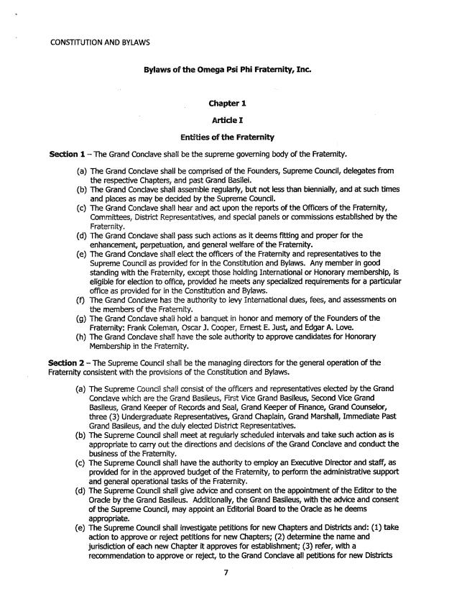

CONSTITUTION ANÍ) BYLAWS
Bylaws of the Omega Psi Phi Fraternity, Inc.
Chapter 1
Article I
Entities of the Fraternity
Section 1 – The Grand Conciave shall be the supreme governing body of the Fraternity.
(a) The Grand Conclave shall be comprised of the Founders, Supreme Council, delegates from
the respective Chapters, and past Grand Basilei. (b) The Grand Conclave shall assemble regularly, but not less than biennially, and at such times
and places as may be decided by the Supreme Council. (c) The Grand Conclave shall hear and act upon the reports of the Officers of the Fraternity,
Committees, District Representatives, and special panels or commissions established by the Fraternity. (d) The Grand Conclave shall pass such actions as it deems fitting and proper for the
enhancement, perpetuation, and general welfare of the Fraternity. (e) The Grand Conclave shall elect the officers of the Fraternity and representatives to the Supreme Council as provided for in the Constitution and Bylaws. Any member in good standing with the Fraternity, except those holding International or Honorary membership, is eligible for election to office, provided he meets any specialized requirements for a particular office as provided for in the Constitution and Bylaws. (f) The Grand Conclave has the authority to levy International dues, fees, and assessments on
the members of the Fraternity. (g) The Grand Conclave shall hold a banquet in honor and memory of the Founders of the
Fraternity: Frank Coleman, Oscar J. Cooper, Ernest E. Just, and Edgar A. Love. (h) The Grand Conclave shals have the sole authority to approve candidates for Honorary
Membership in the Fraternity.
Section 2 – The Supreme Council shall be the managing directors for the general operation of the Fraternity consistent with the provisions of the Constitution and Bylaws.
(a) The Supreme Councii shall consist of the officers and representatives elected by the Grand
Conclave which are the Grand Basileus, First Vice Grand Basileus, Second Vice Grand Basileus, Grand Keeper of Records and Seal, Grand Keeper of Finance, Grand Counselor, three (3) Undergraduate Representatives, Grand Chaplain, Grand Marshall, Immediate Past Grand Basileus, and the duly elected District Representatives. (b) The Supreme Council shall meet at regularly scheduled intervals and take such action as is
appropriate to carry out the directions and decisions of the Grand Conclave and conduct the business of the Fraternity. (c) The Supreme Council shall have the authority to employ an Executive Director and staff, as
provided for in the approved budget of the Fraternity, to perform the administrative support and general operational tasks of the Fraternity. (d) The Supreme Council shalf give advice and consent on the appointment of the Editor to the
Orade by the Grand Basileus. Additionally, the Grand Basileus, with the advice and consent of the Supreme Council, may appoint an Editorial Board to the Oracle as he deems appropriate. (e) The Supreme Council shall investigate petitions for new Chapters and Districts and: (1) take
action to approve or reject petitions for new Chapters; (2) determine the name and jurisdiction of each new Chapter it approves for establishment; (3) refer, with a recommendation to approve or reject, to the Grand Conclave all petitions for new Districts
7

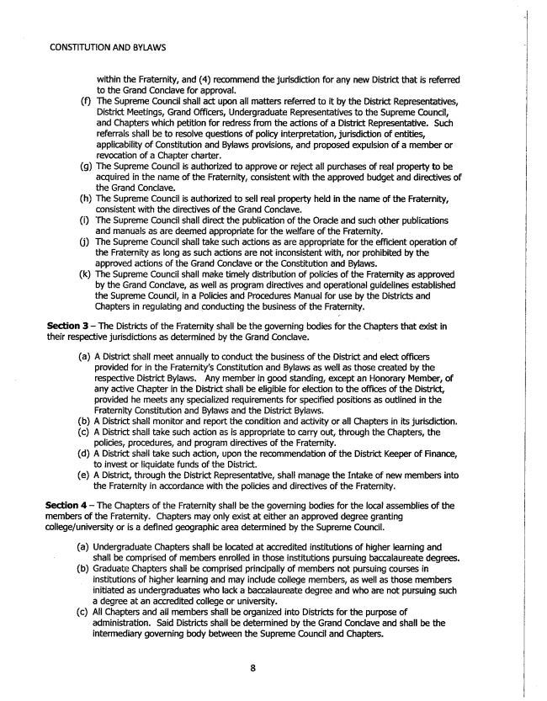

CONSTITUTION AND BYLAWS
within the Fraternity, and (4) recommend the jurisdiction for any new District that is referred to the Grand Conclave for approval. (f) The Supreme Council shalf act upon all matters referred to it by the District Representatives,
District Meetings, Grand Officers, Undergraduate Representatives to the Supreme Council, and Chapters which petition for redress from the actions of a District Representative. Such referrals shall be to resolve questions of policy interpretation, jurisdiction of entities, applicability of Constitution and Bylaws provisions, and proposed expulsion of a member or revocation of a Chapter charter. (g) The Supreme Council is authorized to approve or reject all purchases of real property to be
acquired in the name of the Fraternity, consistent with the approved budget and directives of the Grand Conclave. (h) The Supreme Council is authorized to sell real property held in the name of the Fraternity,
Consistent with the directives of the Grand Conclave. (i) The Supreme Council shall direct the publication of the Oracle and such other publications
and manuals as are deemed appropriate for the welfare of the Fraternity. (j) The Supreme Council shall take such actions as are appropriate for the efficient operation of
the Fraternity as long as such actions are not inconsistent with, nor prohibited by the approved actions of the Grand Conclave or the Constitution and Bylaws. (k) The Supreme Council shall make timely distribution of policies of the Fraternity as approved by the Grand Conclave, as well as program directives and operational guidelines established the Supreme Council, in a Policies and Procedures Manual for use by the Districts and Chapters in regulating and conducting the business of the Fraternity.
Section 3 – The Districts of the Fraternity shall be the governing bodies for the Chapters that exist in their respective jurisdictions as determined by the Grand Conclave.
(a) A District shall meet annually to conduct the business of the District and elect officers
provided for in the Fraternity's Constitution and Bylaws as well as those created by the respective District Bylaws. Any member in good standing, except an Honorary Member, of any active Chapter in the District shall be eligible for election to the offices of the District, provided he meets any specialized requirements for specified positions as outlined in the Fraternity Constitution and Byfaws and the District Bylaws. (b) A District shall monitor and report the condition and activity or all Chapters in its jurisdiction. (c) A District shall take such action as is appropriate to carry out, through the Chapters, the
policies, procedures, and program directives of the Fraternity. (d) A District shah take such action, upon the recommendation of the District Keeper of Finance,
to invest or liquidate funds of the District, (e) A District, through the District Representative, shall manage the Intake of new members into
the Fraternity in accordance with the policies and directives of the Fraternity.
Section 4 – The Chapters of the Fraternity shall be the governing bodies for the local assemblies of the members of the Fraternity. Chapters may only exist at either an approved degree granting college/university or is a defined geographic area determined by the Supreme Council.
(a) Undergraduate Chapters shall be located at accredited institutions of higher learning and
shall be comprised of members enrolled in those institutions pursuing baccalaureate degrees.
(b) Graduate Chapters shall be comprised principally of members not pursuing courses in
institutions of higher learning and may include college members, as well as those members initiated as undergraduates who lack a baccalaureate degree and who are not pursuing such a degree at an accredited college or university.
(c) All Chapters and all members shall be organized into Districts for the purpose of
administration. Said Districts shall be determined by the Grand Conclave and shall be the intermediary governing body between the Supreme Council and Chapters.

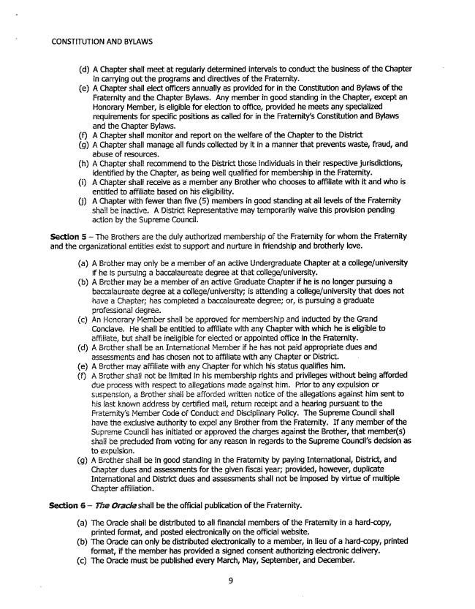

CONSTITUTION AND BYLAWS
(d) A Chapter shall meet at regularly determined intervals to conduct the business of the Chapter
in carrying out the programs and directives of the Fraternity. (e) A Chapter shall elect officers annually as provided for in the Constitution and Bylaws of the
Fraternity and the Chapter Bylaws. Any member in good standing in the Chapter, except an Honorary Member, is eligible for election to office, provided he meets any specialized requirements for specific positions as called for in the Fraternity's Constitution and Bylaws and the Chapter Bylaws, (f) A Chapter shall monitor and report on the welfare of the Chapter to the District (g) A Chapter shall manage all funds collected by it in a manner that prevents waste, fraud, and
abuse of resources. (h) A Chapter shall recommend to the District those individuals in their respective jurisdictions,
identified by the Chapter, as being well qualified for membership in the Fraternity. (i) A Chapter shall receive as a member any Brother who chooses to affiliate with it and who is
entitled to affiliate based on his eligibility. (j) A Chapter with fewer than five (5) members in good standing at all levels of the Fraternity
shail be inactive. A District Representative may temporarily waive this provision pending action by the Supreme Council. -
Section 5 – The Brothers are the duly authorized membership of the Fraternity for whom the Fraternity and the organizational entities exist to support and nurture in friendship and brotherly love.
(a) A Brother may only be a member of an active Undergraduate Chapter at a college/university
if he is pursuing a baccalaureate degree at that college/university. (b) A Brother may be a member of an active Graduate Chapter if he is no longer pursuing a
baccalaureate degree at a college/university; is attending a college/university that does not have a Chapter; has completed a baccalaureate degree; or, is pursuing a graduate professional degree. (c) An Honorary Member shall be approved for membership and inducted by the Grand
Conclave. He shall be entitled to affiliate with any Chapter with which he is eligible to affiliate, but shall be ineligible for elected or appointed office in the Fraternity. (d) A Brother shall be an International Member if he has not paid appropriate dues and
assessments and has chosen not to affiliate with any Chapter or District. (e) A Brother may affiliate with any Chapter for which his status qualifies him. (f) A Brother shali not be imited in his membership rights and privileges without being afforded
due process with respect to allegations made against him. Prior to any expulsion or suspension, a Brother shall be afforded written notice of the allegations against him sent to his jast known address by certified mail, return receipt and a hearing pursuant to the Fraternity's Member Code of Conduct and Disciplinary Policy. The Supreme Council shall have the exclusive authority to expel any Brother from the Fraternity. If any member of the Supreme Council has initiated or approved the charges against the Brother, that member(s) shall be precluded from voting for any reason in regards to the Supreme Council's decision as to expulsion. (g) A Brother shall be in good standing in the Fraternity by paying International, District, and Chapter dues and assessments for the given fiscal year; provided, however, duplicate International and District dues and assessments shall not be imposed by virtue of multiple
Chapter affiliation.
Section 6 — The Oracle shall be the official publication of the Fraternity.
(a) The Oracle shall be distributed to all financial members of the Fraternity in a hard-copy,
printed format, and posted electronically on the official website.
(b) The Oracle can only be distributed electronically to a member, in lieu of a hard-copy, printed
format, if the member has provided a signed consent authorizing electronic delivery.
(c) The Oracle must be published every March, May, September, and December.
9

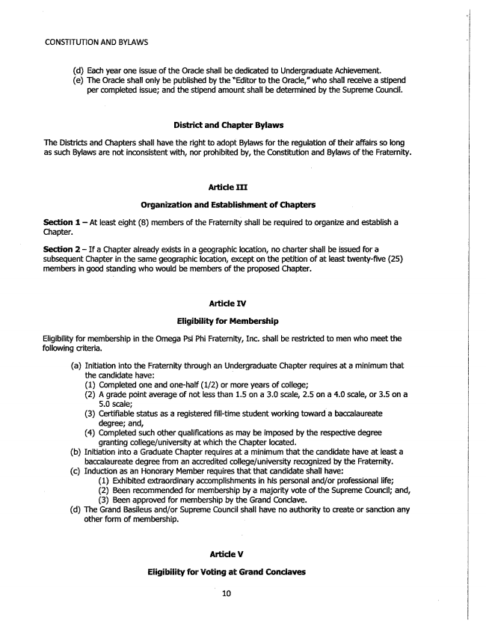

CONSTITUTHON AND BYLAWS
(d) Each year one issue of the Oracle shall be dedicated to Undergraduate Achievement. (e) The Oracle shall only be published by the “Editor to the Oracle,” who shall receive a stipend
per completed issue; and the stipend amount shall be determined by the Supreme Council.
District and Chapter Bylaws
The Districts and Chapters shall have the right to adopt Bylaws for the regulation of their affairs so long as such Bylaws are not inconsistent with, nor prohibited by, the Constitution and Bylaws of the Fraternity.
Article III
Organization and Establishment of Chapters
Section 1 – At least eight (8) members of the Fraternity shall be required to organize and establish a Chapter.
Section 2 – If a Chapter already exists in a geographic location, no charter shall be issued for a subsequent Chapter in the same geographic location, except on the petition of at least twenty-five (25) members in good standing who would be members of the proposed Chapter.
Articfe IV
Eligibility for Membership
Eligibility for membership in the Omega Psi Phi Fraternity, Inc. shall be restricted to men who meet the following criteria.
(a) Initiation into the Fraternity through an Undergraduate Chapter requires at a minimum that
the candidate have: - (1) Completed one and one-half (1/2) or more years of college; (2) A grade point average of not less than 1.5 on a 3.0 scale, 2.5 on a 4.0 scale, or 3.5 on a
5.0 Scale; (3) Certifiable status as a registered fill-time student working toward a baccalaureate
degree; and, (4) Completed such other qualifications as may be imposed by the respective degree
granting college/university at which the Chapter located. (b) Initiation into a Graduate Chapter requires at a minimum that the candidate have at least a
baccalaureate degree from an accredited college/university recognized by the Fraternity. (c) Induction as an Honorary Member requires that that candidate shall have:
(1) Exhibited extraordinary accomplishments in his personal and/or professional life; (2) Been recommended for membership by a majority vote of the Supreme Council; and, (3) Been approved for membership by the Grand Conclave. (d) The Grand Basileus and/or Supreme Council shall have no authority to create or sanction any
other form of membership. .
Article V
Eiigibility for Voting at Grand Conciaves

- Amendments clause
a.”All amendments to this Constitution shall not be valid until approved by the Constitution Committee and the Student Senate.”

2. DIssolution clause
- “If this organization is dissolved, any remaining allocated funds shall be forfeited to the Student Senate, after all outstanding bills are paid.”

